**Cryptography and Network Security**

**Assignment 14 – Generation of digital Certificate**

Name: Vaishnavi Santosh Bhajibhakare

PRN: 2019BTECS00039

Batch: B2

**Problem statement :** Generation of digital certificate using java key tool and key store utilities or by using open SSL

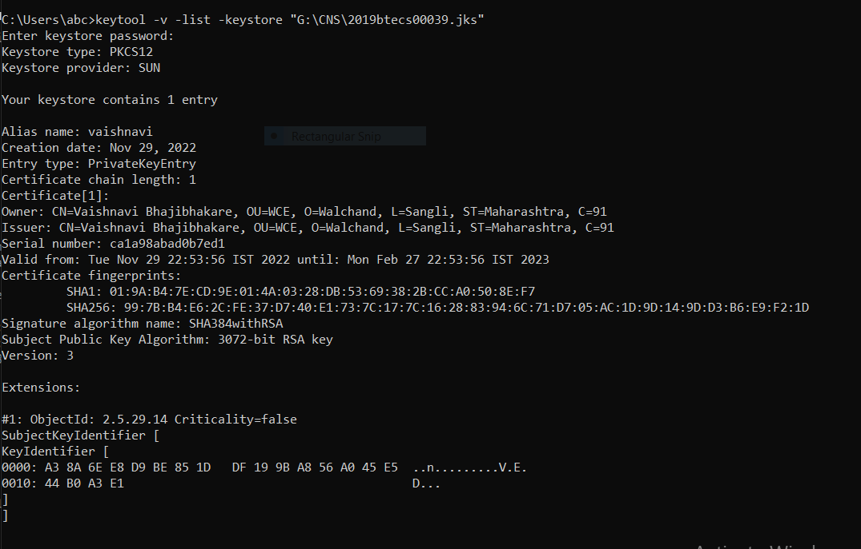

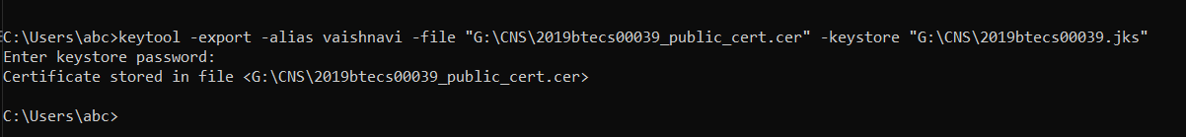

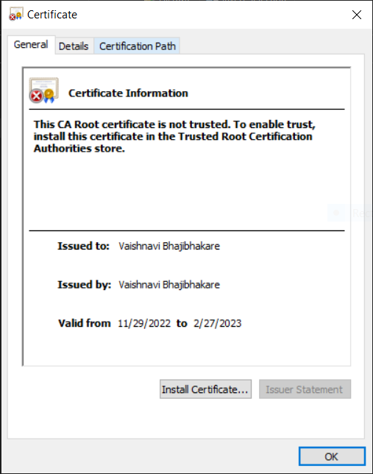

**Applications :**

- Digital certificates are used for to secure email to identify one user to another

- It may also used for electronic document signing.